SSDT XML Bug

# Bug Scenario

* Stored procedure holding an xml query
* Stored procedure definition is changed in SSDT to change case of node name
* Ignore keyword casing = False
* SSDT does not see the difference

# Replication Steps

* Open SSDTXMLBug.sln
* Publish SSDTXMLBug database to your local
* Go to Tools > New Schema Comparison
* Use SSDTXMLBug project as source
* Use localhost.SSDTXMLBug as target
* Select the settings cog and ensure that Ignore Keyword casing is unticked

* Ensure that ignore comments is also unticked

* Run Schema compare, you should have no results
* Amend xmlExample stored procedure in the project and change the case as shown below:

**Before**

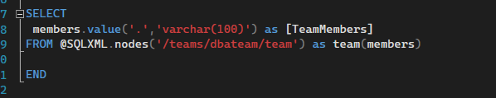

**After**

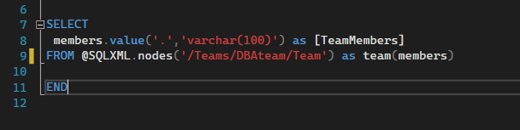

* Rebuild the project
* Run your schema compare again
* SSDT shows no difference, even though the case change I have just made will mean any queries will now fail if it using the wrong case.
* Now if we add a comment to the sproc to try and coax a difference out

* Rebuild solution again
* Run Schema compare again

* Notice it has now flagged the comment as a change, it also has the case change as a difference, but it will not flag that without another change on the file.